Project Name – Incredible India

JQuery Features used

**Drop Down Menu**



On mouseover drop drop menu is displayed and on mouseout drop down menu is hidden.

Also on mouseover in drop down menu, font size of the menu increases and vice versa.

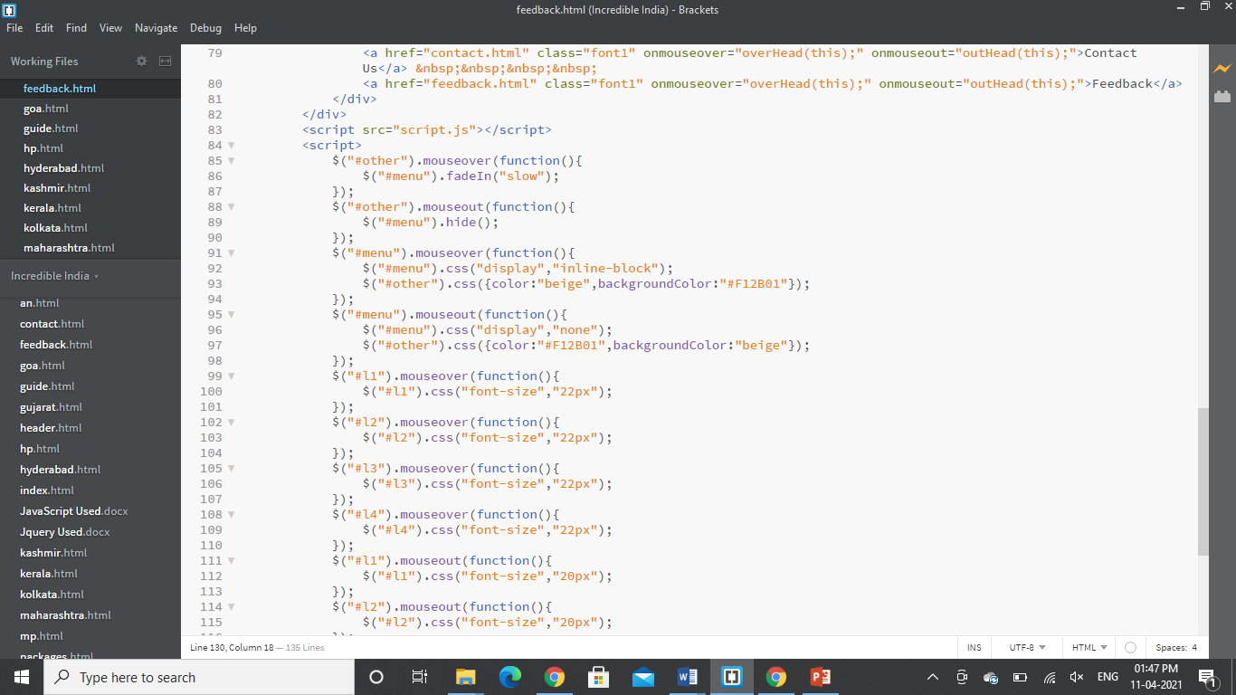

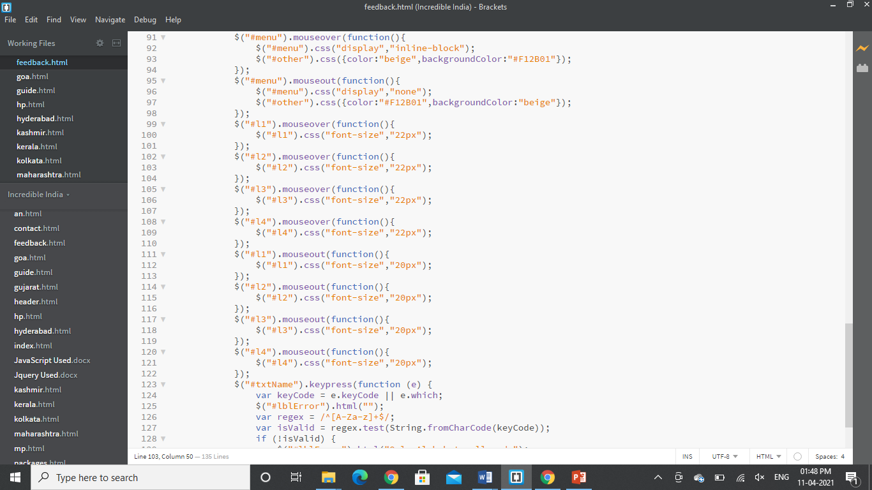

**Scroll to top**



On clicking this symbol, it scrolls to the top of the web page.

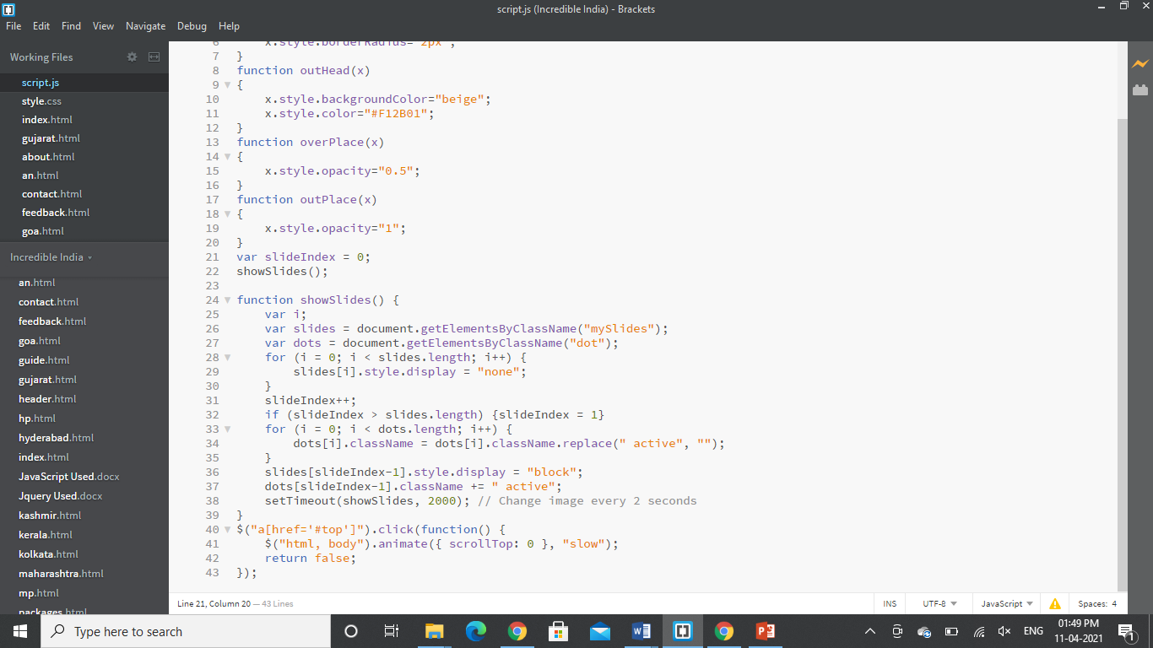

**Sliding Panel**

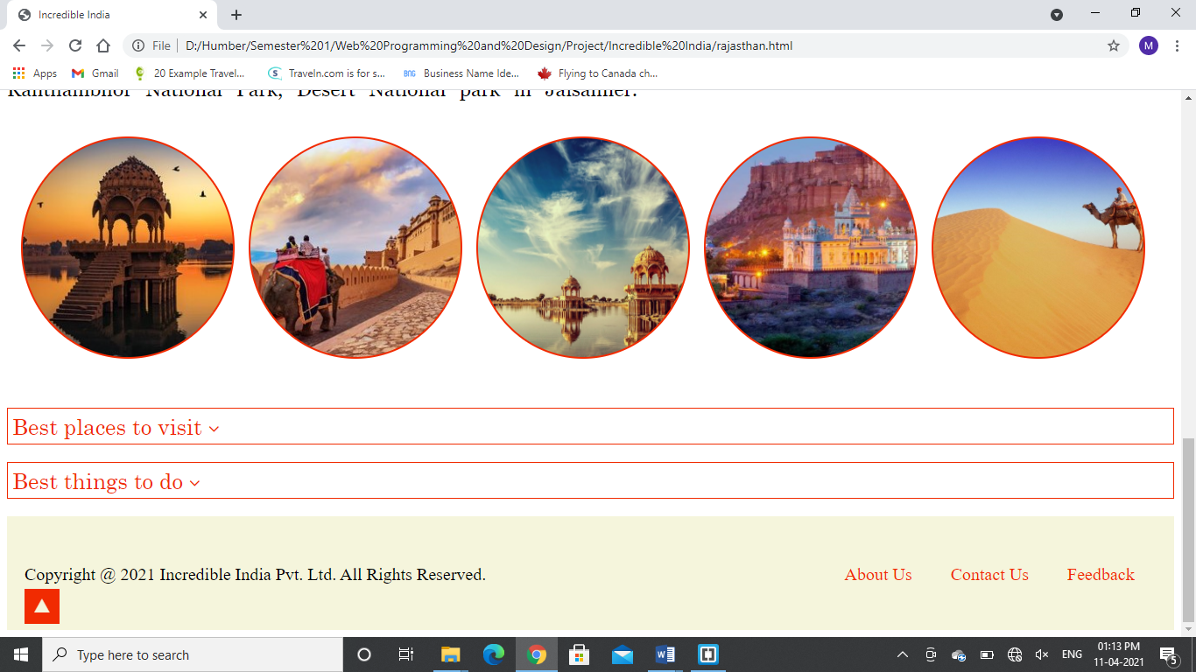

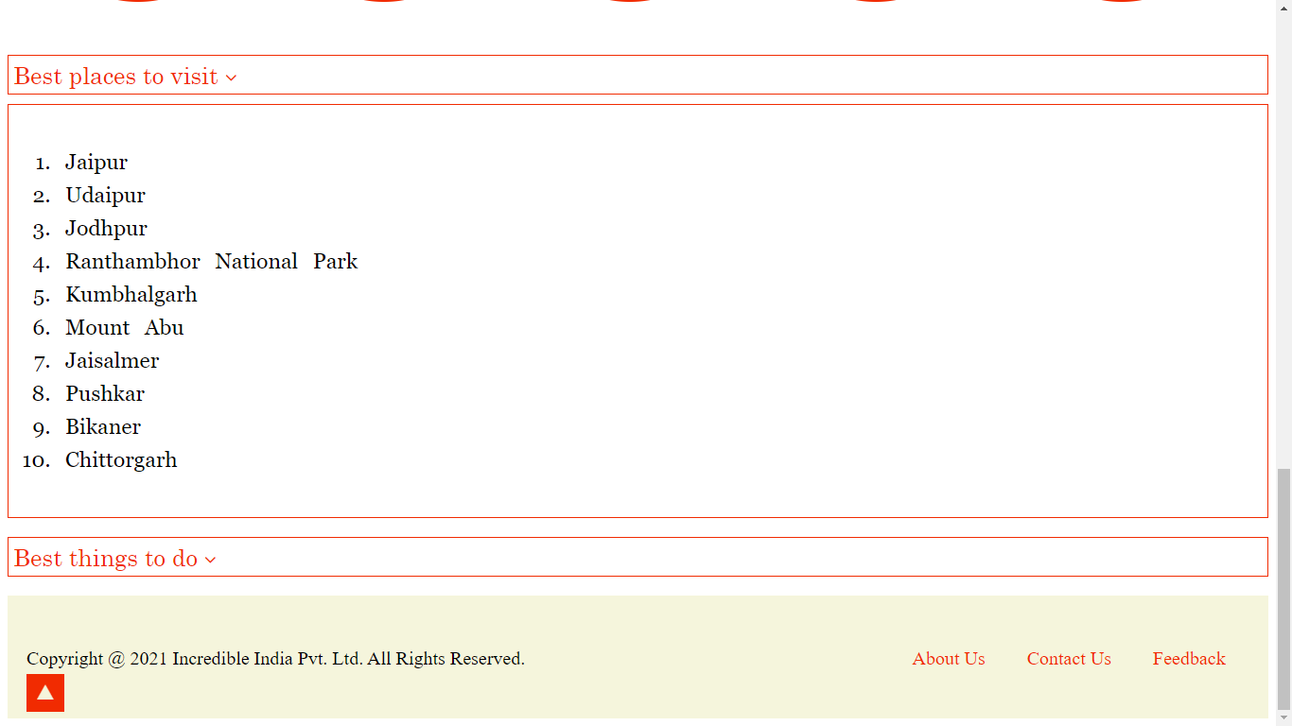

On click the slide toggles between hide and show.

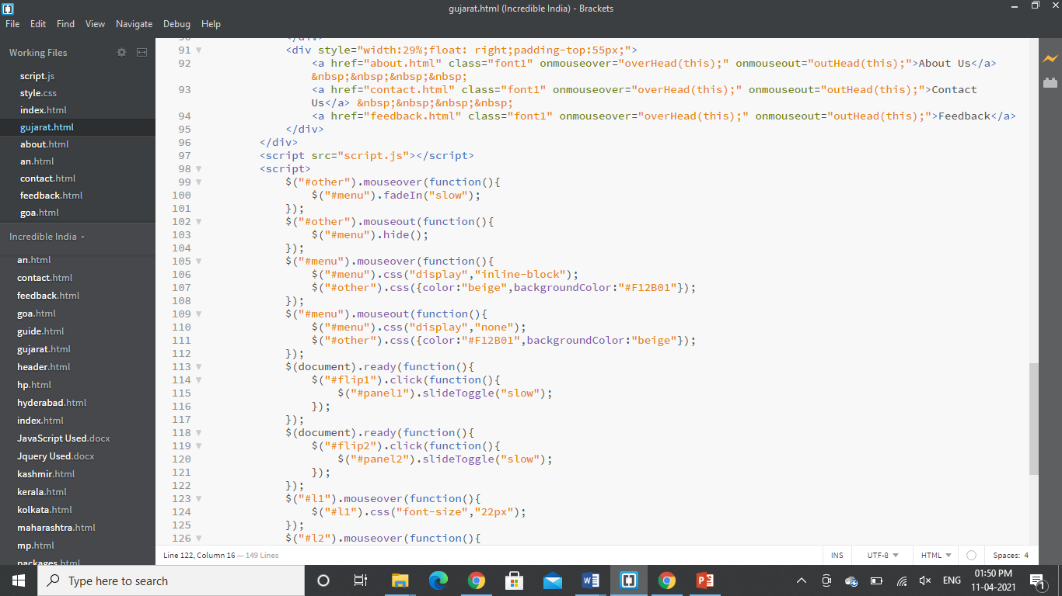

**Alphabets allowed**

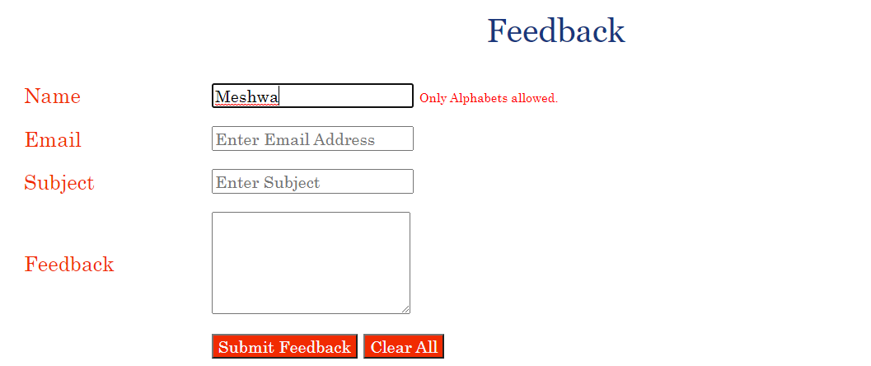

Name textbox that accepts only alphabets and spaces.

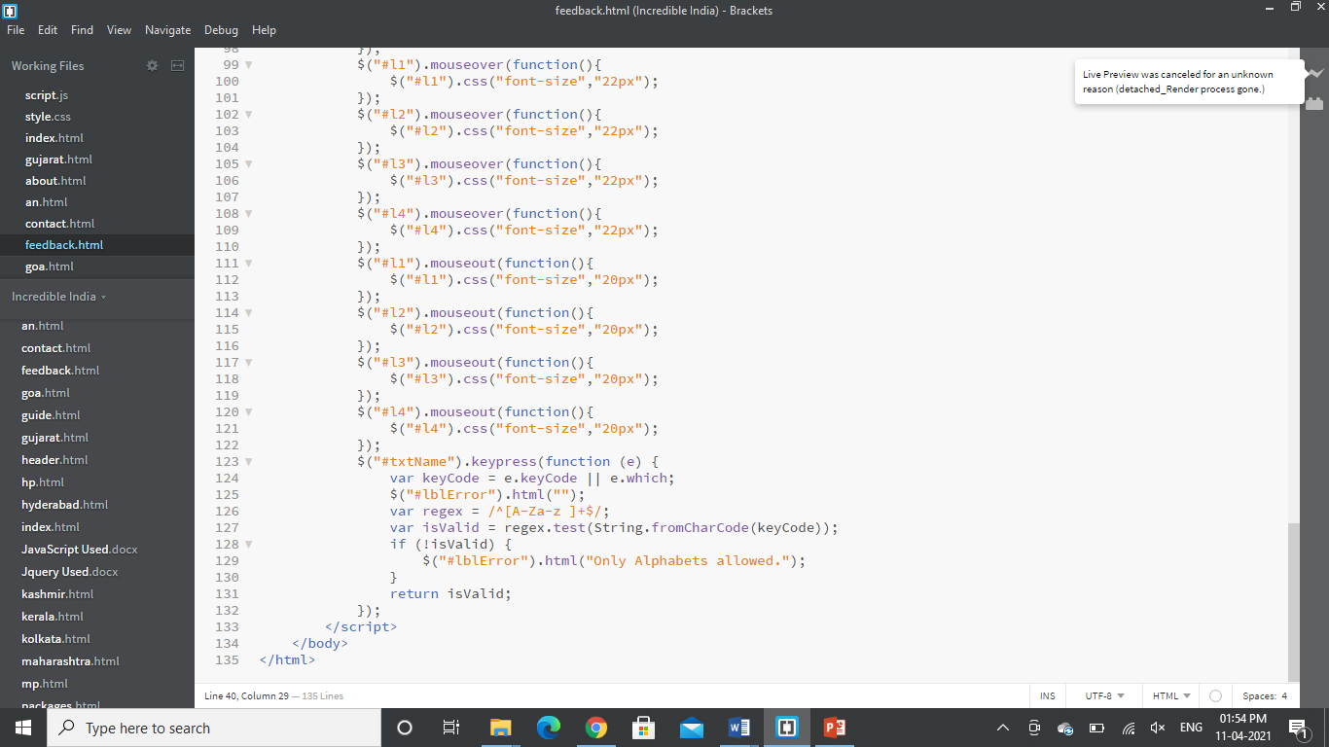

**Validating Sign Up Form**

